The Time When the Roads weren’t too Good

Narrated by Stanley Skoe, April 2003 – Stanley was 87 at the time of this narration

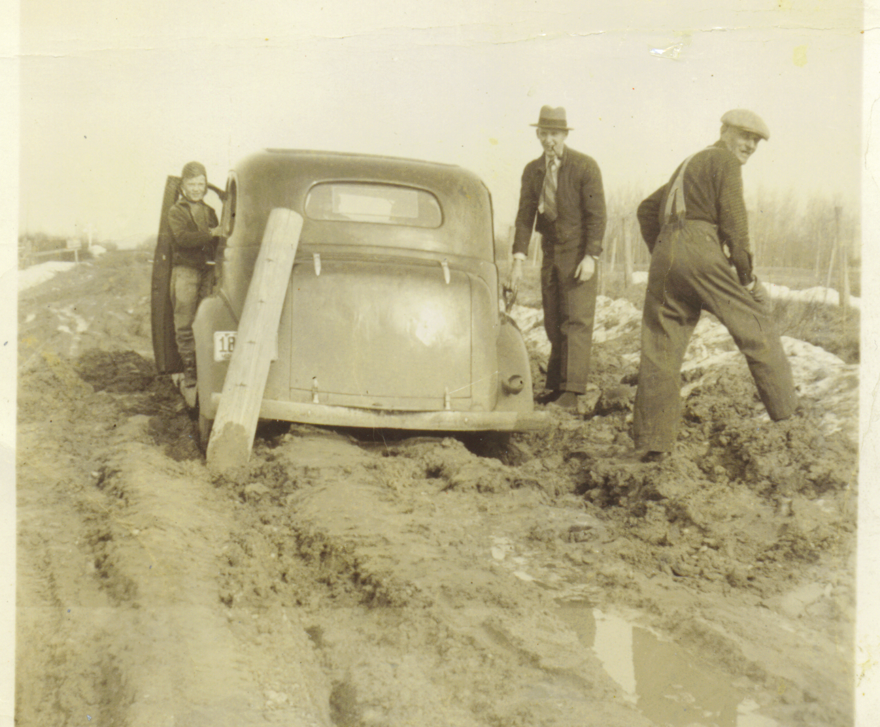

Figure 1: Road to Mizpah

Table of Contents

Corduroy road around Island Lake 2
Winter Roads around Island Lake 2
Highway 46 3
Road to Mizpah 3
Orth Road 3
Washboard Roads 4
Park Avenue 4
Bulldozers 4
Trail between Island Lake and Blackduck 5
Sinkholes 5

Corduroy road around Island Lake

At the south end of Island Lake there were tamarack swamps and bogs and of course the old Skoe Farm, where you (Ralph Skoe) lives now was right in the center of these bogs and that was were the last portions of the Island Lake road were completed.

Previously, it was kind of a wagon trail and to get through the bogs and tamarack swamps they corduroyed the road. The corduroy was a pretty rough and nobody really took care of it. You could get through with a team and wagon, pretty much an empty wagon. You could not haul a load across and it almost impossible for a car. Although, once in a while, some poor brave soul would attempt it and perhaps made it across the corduroy. Well, then the corduroy keep getting worse. They were trying to get a road to have traffic around the lake so they abandoned most the corduroy parts, and that is when , they build the road close to the Grealy Place (previous called the Cedars and now owned by someone from Indianapolis) and around the point past where the Skoe Cabin is. Then graded and filled in the bog. This kind of completed the road around the lake. Although, it was still like most roads in those days, very seasonal.

Winter Roads around Island Lake

In the wintertime you could get around fine as long as the snow didn’t get to bad. Even with cars since the roads would freeze and we didn’t have the mud. But then, the snow would drift in and we were back to horses and sleds. The cars waited then till breakup. When the breakup came it took quite a while for the roads to dry up to get rid of the mud and the ruts so that you could get through with a car.

Much of this occurred during the late 20’s and continued on until after the end of the War before the road was completed and graveled and it was safe to call it a year around road. At least, so there weren’t mud holes, ruts and places to get stuck.

Back in the 20’s and early 30’s we didn’t have mail delivery around our end of the Lake. We got our mail at Bergville, which was two miles away. That’s where the school was. So when the new Bergville school was opened, I guess the post office was closed about that time, we had a mailman delivering the mail. I remember one nice, wintry day the mailman came walking up to the house covered up with snow, looking a little disgusted. “What’s the trouble”, we asked. “I am stuck with my team of horse in a snow bank”, responded. Well, I was pretty small so I didn’t get in on it, but Earl, Stanton, and Pa got their shovels and they shoveled the mailman out. He was stuck in one particular spot there on the south end of Island Lake where the wind blew in off the lake and the drifting was horrendous.

It was quite frequently that the snowdrifts would be up to the top of the telephone poles. Of course, now they have snowplows and other means of keeping the road open. Also, the shuddery was not grown up along the lake to give a little windbreak. I don’t thing there is the drifting that we used to get. In fact, it used to drift so bad that they build a winter road. Well, a winter road is nothing but an old logging trail that was used by the loggers in the wintertime. It was away from the lake far enough so it never drifted. Both the horses and the cars would use that winter road.

Highway 46

The roads from Northome to Bergville is highway 46. I don’t know what the number was in those days. When they built that road, the first thing they had was a wagon trail. When they started to grade and fill the road, if there was a little low or hill, they didn’t go through it instead they went around it. Or, if there was a pothole or soft spot they’d go around that. So the road for Bergville to Northome, while it was generally pretty good, meaning you could get through without getting stuck or having serious trouble, was so damned crooked. It had curves in it you couldn’t believe. Then later in years, I don’t remember the year, they rebuilt highway 46 and put a road straight through. In this case they filled the potholes and swamps, cut the hills down, and made a nice straight road which is the highway in use today.

One other problem with the roads those days was, if you had a wet year or in the spring, the roads would be so cockeyed slippery than when a track formed in the middle of the road everybody stayed in that track. Pretty all four wheels were almost up to the hubs in these ruts. Still, it worked pretty good. You generally didn’t get stuck. Once in a while you would get high centered. When a car came from the other direction you had no choice but to get out and decided which one had to back out the farthest so they could get by. Since the cars were in the same set of ruts facing each other. This usually worked out pretty we;;. I never heard of any arguments or anybody getting in to any fights over who had to do the backing up. It was quite a common problem.

Road to Mizpah

Even some of the so-called better roads had problems. I remember on time on Saturday night and a bunch of us were going to go to a dance in Mizpah. I think it was Lloyd Anderson, Melvin Nesseth, Rod Matheson and myself. We really got stuck (refer to the picture); we were in the mud up to the hubs. We got a hold of a bunch of planks and boards and logs and we finally got ourselves out. In fact I am going to send you a snapshot for that same day. I don’t know how I hung on to that one picture this long. That picture is actually on the road between Northome and Mizpah back in about 31 or 32.
It must be me with the hat. I believe it was Lloyd Allen’s car. The other has to be Rod Matheson and Melvin Nesseth must have taken the picture.

Orth Road

Another rather interesting sidelight on the roads was the old Orth road. They had the same problems everybody else had. They had a road but gravel was had to get. You know we didn’t have a bunch of trucks to go hauling it. It had to be hauled with horse and wagon. There apparently were not gravel pits near the Orth Road and it had some kind of clay or gumbo. All the people who lived out there said it was the stickiest, toughest clay or anyplace in the world. They all thought there must be something that the Orth clay could be used for besides screwing up a road and that was quite a topic of conversation; that Orth road gumbo. I guess it was pretty bad. I don’t think I ever drove on that road probably for the very reason it was so tough to drive on.

Washboard Roads

Another problem we had on roads usually occurred on sandy roads. Right around Island Lake we didn’t have any sand, but on the road heading towards Grand Rapids, and I believe towards Bemidji, were areas that were kind of sandy. They build the roads nice and straight and perfect; no mud, no ruts. But boy, would they get washboardy. That washboard was so bad that sometimes, with those old cars, you had a hard time holding them on the road. You thought they were going to fall apart. That washboard was persistent. We could run though with a blade and smooth it off. Then the road looked perfect but after just a few cars passed over we were right back to the washboard; probably worst than ever. Some of those roads, until they finally got around to paving, were always washboard.

Park Avenue

Another example of really bad road, was the road east of Northome, I think it was call Highway 1. Back then everybody called it Park Avenue. I guess we called it Park Avenue because it was so horribly bad. They also had a clay there that was unbelievable. In the spring the schools were closed for certain periods of time, sometimes maybe long periods. There just was no way to get into town on that road with an automobile. Horses or walking was the only way. I don’t know what years it was when the finally got that road cleanup so that it was usable in all weather. I do remember back in, I am going to say, 1937 maybe a little earlier, I had a truck at that time. We had quite a project going grading and rebuilding that road. I guess after that they kept working on it. I haven’t drove on it recently but I guess it is a pretty good highway now.

Bulldozers

A lot of people who drive on our nice smooth asphalt and paved road now don’t realize that the nasty bulldozer is what made it possible to build the present day roads. I guess it’s true that the bulldozer have ripped up to much landscape in America but without them we might still be bouncing around on crooked roads and around swamps and the hills instead of though them and over them. So I guess the old bulldozer is pretty good. I did a little of it myself.

I did quite a bit of bulldozer work helping to build the Alaska Highway. I guess there is a side thought about that. It was so damn cold up there in the winter, I spent the whole winter there, that we never shut the engines on the bulldozer. If for some reason, we had to shut the engine down, they would have to tow the bulldozers to start them. Anyway they were great road builders even if they did make a lot of people a little bit unhappy.

Trail between Island Lake and Blackduck

I am going to add one little part in here about when father first homesteaded on the place. At that time there were no wagon trails, horse trails, probable just Indian trails; at least there were no roads or trails to speak of. At that time, the train tracks stopped at Blackduck.. I am not sure what year it actually arrived at Blackduck, but I remember our father talking about that he had to pack everything from Blackduck to the homestead on Island Lake with a packsack. They didn’t even have a horse; they didn’t have anything. He had a neighbor, I think his name was Karl Magnusson (Carl Magnuson) who had a homestead just east of ours. So they kind of worked together. They had to get a cook stove so they both walked to Blackduck and bought one. I don’t know how big it was. I think it was just a cook stove that didn’t have an oven. Anyway, it was pretty heavy carrying it. When they got half way home they were so tried out carrying that think in the packsack, that they hid it off in the brushes someplace; went home. Sleep and rested up for a day or so, then went back and got the cook stove. So at least then they had something to cook on. I never saw the stove and I don’t know what every happened to it. They not only had to carry the cook stove but they had to carry all their food such as coffee. He had build himself a little log hut, kind of a log cabin. For the roof, they used birch bark and then throw dirt on top of the birch bark. Somehow they got a bunch of turnip seeds up there and had a good crop of turnips on the roof of the cabin.

Sinkholes

Well, there was one other thing that used to give the roads a lot of troubles in the old days. There weren’t very many of them and we called them sinkholes. They were places in the road were every time it rained or in the spring of the year when the snow was melting, and some times all summer long, water would stand. Well, they filled them up with gravel but they would keep sinking. One sinkhole was by the hill at the Bergville Cemetery. For years and years we had to slow down and go through in low gear and the water would be high enough so if you went to fast you were likely to drowned out the motor and not make it. If you went slow you got though alright. They would go in there and lay down logs crossways and then cover them with dirt to make a road. It would just keep sinking, did it for years. It would sink so slow you couldn’t see it. I don’t know if I have driven over the sinkhole near the Bergville Cemetery that many times in the last 20 years and I haven’t seen any sign of a sinkhole. I guess they have them all filled in. There are others along highway 46 going to Grand Rapids. There were several, one was right there at Bergville. At some of the worst ones, the farmers living near by always had a team of horses hitched up and they would be ready to pull the cars through that got wet. The smart ones that had to go through those waterholes a lot carried a blanket with them. They would tuck that blanket in and around the whole front end of the radiator of the car and drive real slow then they could usually get through. Some how or other, there were sinkholes and always water, but the road underneath was always solid. I don’t know why. I guess it had something to do with the fact that there was sand in it.

You will have noticed my stories more concerns Bergville than it does Northome but as far as we were concerned Northome was home. So I guess what I said would apply to most any place in Northern Minnesota in those times.

